Collections Assignment

//Q1 Write Java code to define List .
// Insert 5 floating point numbers in List, and using an iterator, find the sum of the numbers in List.
import java.util.ArrayList;
import java.util.Iterator;
import java.util.List;
import java.util.Scanner;
public class Ques1 {
public static void main(String[] args) {
List<Float> l1 = new ArrayList<Float>();
Scanner sc=new Scanner(System.in);
System.out.println("Enter 5 Floating Numbers: ");
for (int i = 0; i < 5; i++) {
float f=sc.nextFloat();
l1.add(f);
}
Iterator<Float> i1=l1.iterator();
float sum=0;
while (i1.hasNext()){
sum=i1.next()+sum;
}
System.out.println("Sum of the numbers in list = "+sum);
}
}
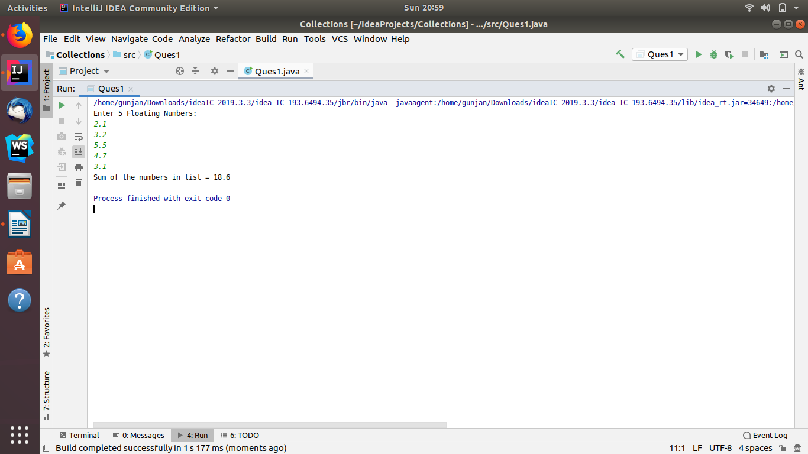

/Q2 Write a method that takes a string and returns the number of unique characters in the string.
import java.util.LinkedHashSet;
import java.util.Scanner;
import java.util.Set;
public class Ques2 {
public static void main(String[] args) {
System.out.print("Enter the String: ");
Scanner sc=new Scanner(System.in);
String s=sc.nextLine();
Set<Character> characters=new LinkedHashSet<Character>();
for (int i=0;i<s.length();i++){
characters.add(s.charAt(i));
}
// System.out.println("Unique Characters in a string are : ");
// for (Character elt:characters)
// System.out.println(elt);
System.out.println("Unique characters in "+s+" are : "+characters);
}
}
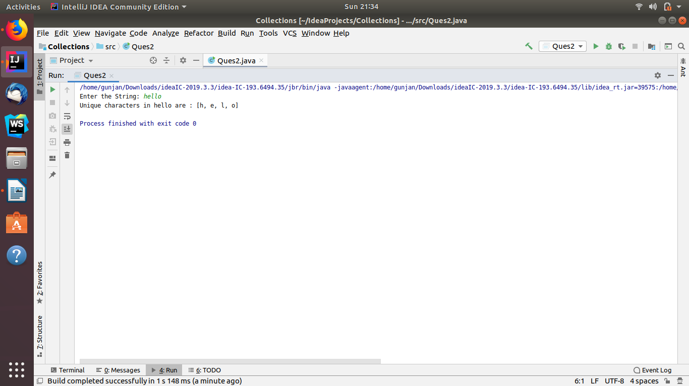

//Q3 Write a method that takes a string and print the number of occurrence of each character characters in the string.
import java.io.*;
import java.util.*;
public class Ques3 {
public static void main(String[] args) {
String str="gunjandawar";
System.out.println("String is : "+str);
System.out.println("Occurrence of each character in a string are : ");
ocurrence(str);
}
public static void ocurrence(String str){
HashMap<Character, Integer> c1 = new HashMap<Character, Integer>();
char[] strArray = str.toCharArray();
for (char c : strArray) {
if (c1.containsKey(c)) {
c1.put(c, c1.get(c) + 1);
}
else {
c1.put(c, 1);
}
}
for (Map.Entry entry : c1.entrySet()) {
System.out.println(entry.getKey() + "-" + entry.getValue());
}
}
}

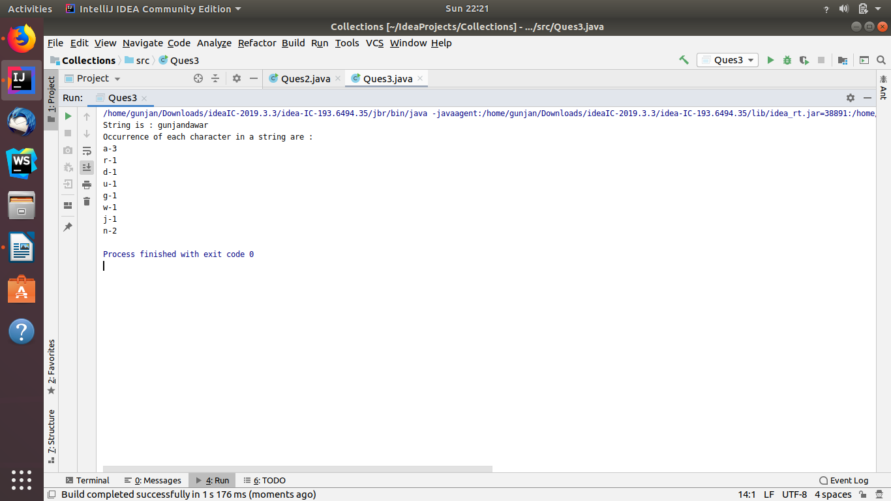

//Q4 Write a program to sort HashMap by value.
import java.util.*;
import java.lang.*;
public class Ques4 {
public static HashMap<String, Integer> sortByValue(HashMap<String, Integer> hm)
{
// Create a list from elements of HashMap
List<Map.Entry<String, Integer> > list = new LinkedList<Map.Entry<String, Integer> >(hm.entrySet());
// Sort the list
Collections.sort(list, new Comparator<Map.Entry<String, Integer> >() {
public int compare(Map.Entry<String, Integer> o1, Map.Entry<String, Integer> o2)
{
return (o1.getValue()).compareTo(o2.getValue());
}
});
// putting data from sorted list to hashmap
HashMap<String, Integer> temp = new LinkedHashMap<String, Integer>();
for (Map.Entry<String, Integer> aa : list) {
temp.put(aa.getKey(), aa.getValue());
}
return temp;
}
public static void main(String[] args)
{
HashMap<String, Integer> hm = new HashMap<String, Integer>();
hm.put("Climate", 9);
hm.put("Entertainment", 7);
hm.put("Sports", 2);
hm.put("Politics", 3);
hm.put("Business", 5);
hm.put("World", 1);
Map<String, Integer> hm1 = sortByValue(hm);
// print the sorted hashmap
for (Map.Entry<String, Integer> en : hm1.entrySet()) {
System.out.println("Key = " + en.getKey() + ", Value = " + en.getValue());
}
}
}
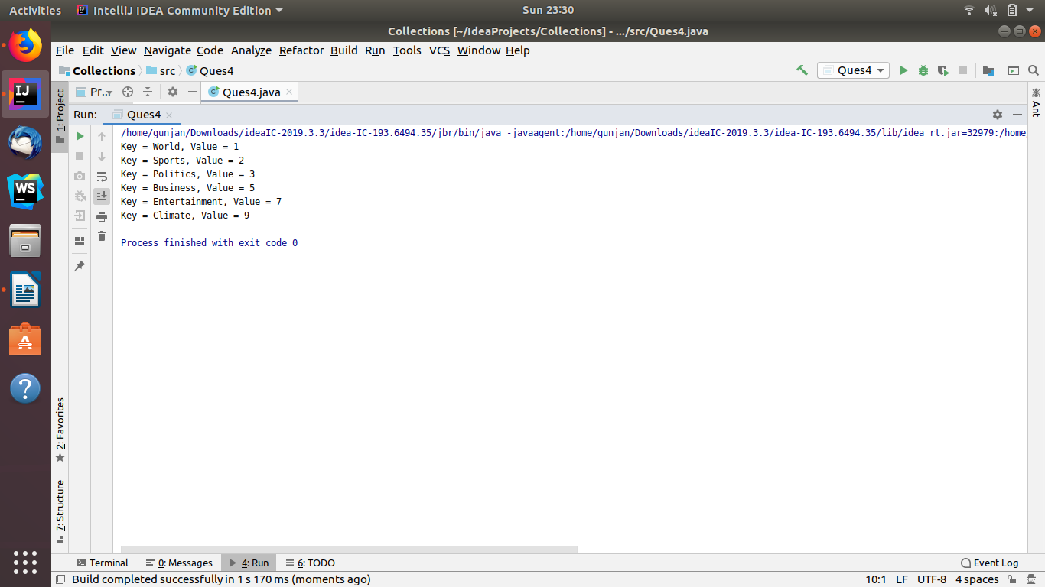

//Q5 Write a program to sort Employee objects based on highest salary using Comparator.
// Employee class{ Double Age; Double Salary; String Name
import java.util.ArrayList;
import java.util.Collections;
import java.util.Comparator;
import java.util.List;
class Employee {
String name = "";
double salary = 0.0;
double age = 0.0;
Employee(String name, double salary, double age) {
this.name = name;
this.salary = salary;
this.age = age;
}
public String toString() {
return "Employee Name : " + name + ", Salary : " + salary + ", Age : " + age +"\n";
}
}
class Mycomp implements Comparator<Employee> {
@Override
public int compare(Employee o1, Employee o2) {
return (int) (o1.salary - o2.salary);
}
}
class Test {
public static void main(String[] args) {
Employee e1 = new Employee("Gunjan", 12000, 20);
Employee e2 = new Employee("Ankur", 8000, 23);
Employee e3 = new Employee("Ramesh", 10000, 20);
Employee e4 = new Employee("Karan", 2000, 26);
List<Employee> employees = new ArrayList<Employee>();
employees.add(e1);
employees.add(e2);
employees.add(e3);
employees.add(e4);
System.out.println("Before Sorting");
System.out.println(employees);
Collections.sort(employees, new Mycomp());
System.out.println("After Sorting");
System.out.println(employees);
}
}

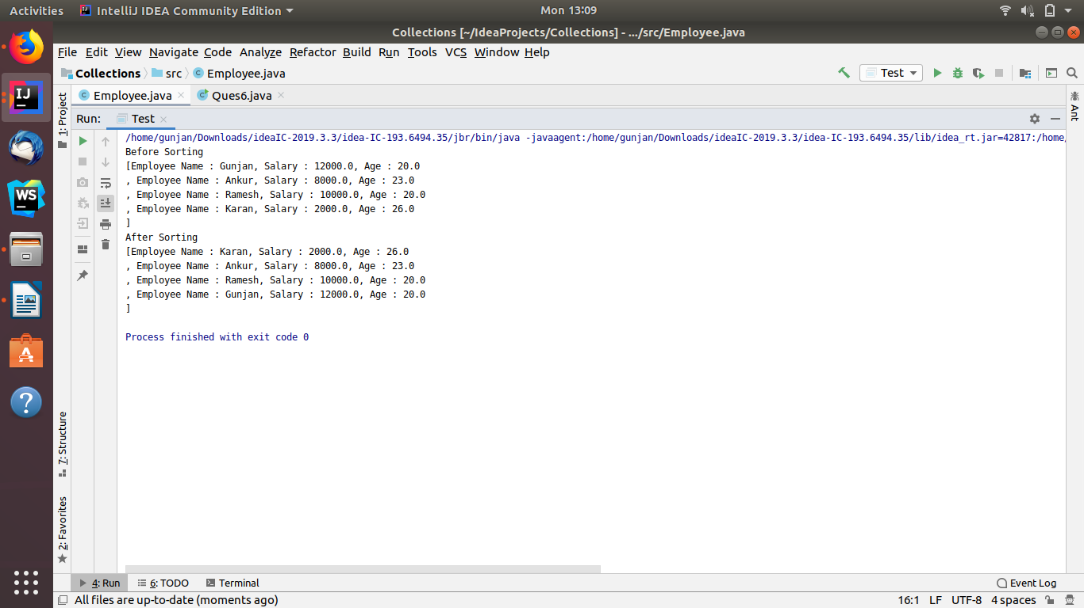

//Q6Write a program to sort the Student objects based on Score , if the score are same then sort on First Name .
// Class Student{ String Name; Double Score; Double Age
import java.util.ArrayList;
import java.util.Collections;
import java.util.Comparator;
import java.util.List;
class Mycompare implements Comparator<Students> {
@Override
public int compare(Students o1, Students o2) {
if (o1.score == o2.score) {
return o1.name.compareTo(o2.name);
} else {
return (int) (o1.score - o2.score);
}
}
}
class Students {
String name = "";
double score = 0.0;
double age = 0.0;
Students(String name, double score, double age) {
this.name = name;
this.score = score;
this.age = age;
}
public String toString() {
return "Employee Name : " + name + ", Score : " + score + ", Age : " + age + "\n";
}
}
public class Ques6 {
public static void main(String[] args) {
Students e1 = new Students("Gunjan", 40, 20);
Students e2 = new Students("Ramesh", 45, 23);
Students e3 = new Students("Ankur", 45, 20);
Students e4 = new Students("Karan", 45, 26);
List<Students> child = new ArrayList<Students>();
child.add(e1);
child.add(e2);
child.add(e3);
child.add(e4);
System.out.println("Before Sorting");
System.out.println(child);
Collections.sort(child, new Mycompare());
System.out.println("After Sorting");
System.out.println(child);
}
}

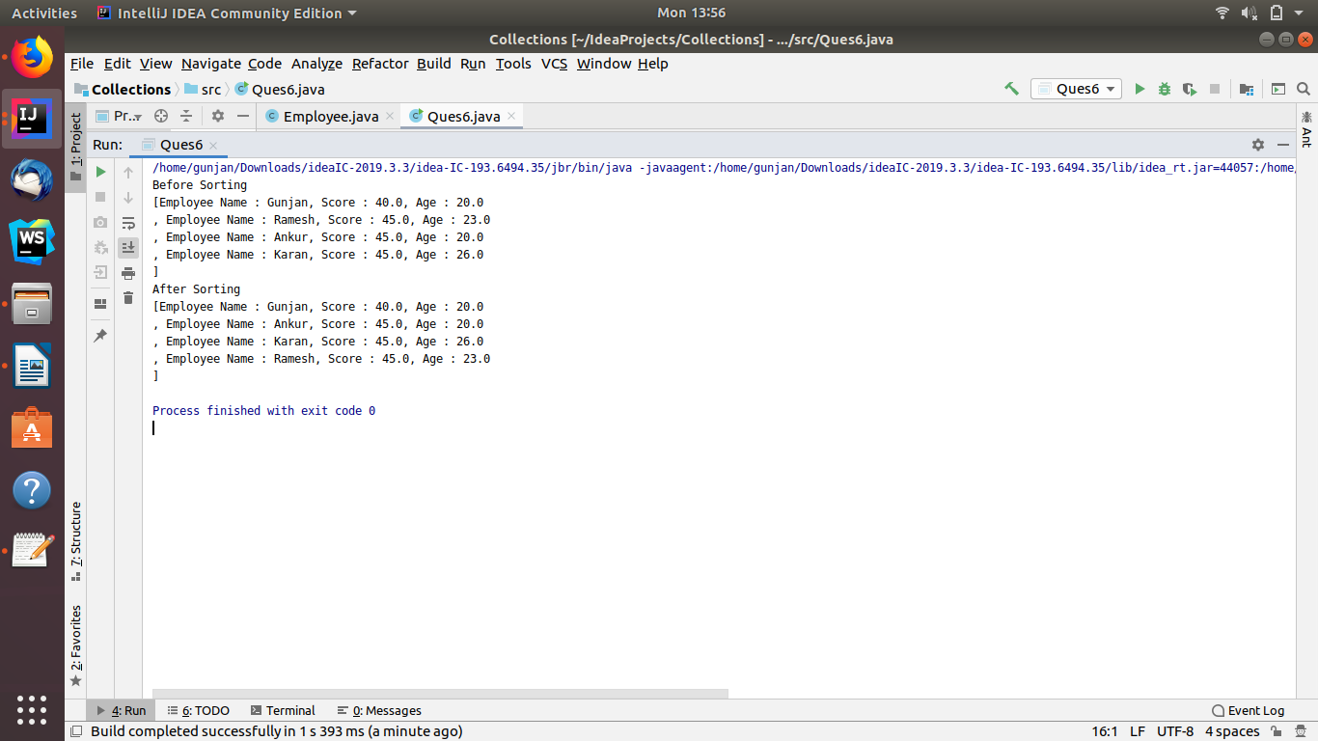

//Q7 Print the elements of an array in the decreasing frequency if 2 numbers have same frequency then print the one which came first.
import java.util.*;
public class Ques7 {
public static void main(String[] args) {
int[] array={1,2,3,2,3,3,4,4};
HashMap<Integer,Integer> hashMap=new HashMap();
for (int i=0;i<array.length;i++){
if(hashMap.containsKey(array[i])){
hashMap.put(array[i],hashMap.get(array[i])+1);
}
else {
hashMap.put(array[i],1);
}
}
List list=new LinkedList(hashMap.entrySet());
CompareTo cmpr=new CompareTo();
Collections.sort(list,cmpr);
System.out.println(list);
}
}
class CompareTo implements Comparator{
@Override
public int compare(Object o1, Object o2) {
return -((Comparable) ((Map.Entry) (o1)).getValue())
.compareTo(((Map.Entry) (o2)).getValue());
}
}
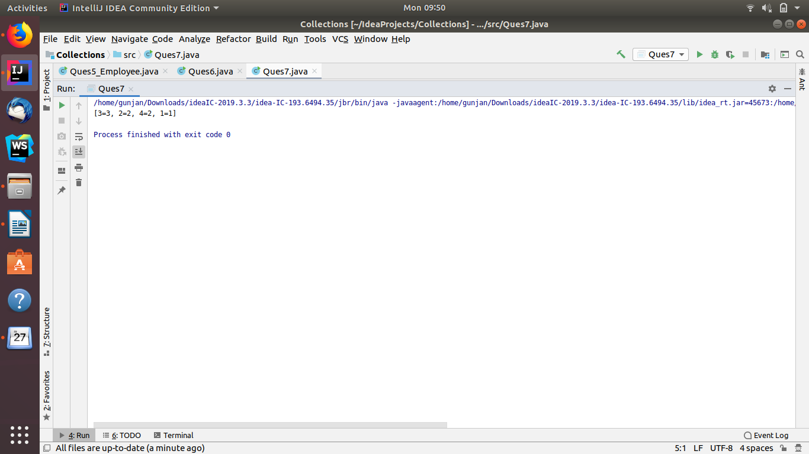

//Q8 Design a Data Structure SpecialStack that supports all the stack operations like push(), pop(), isEmpty(), isFull() and an additional operation getMin() which should return minimum element from the SpecialStack. (Expected complexity O(1))
import java.util.Stack;
public class Ques8 {
Stack<Integer> stack;
Integer min;
Ques8() {
stack = new Stack<Integer>();
}
void getMin() {
if (stack.isEmpty())
System.out.println("Stack is empty");
else
System.out.println("Minimum Element in the " + " stack is: " + min);
}
void peek() {
if (stack.isEmpty()) {
System.out.println("Stack is empty ");
return;
}
Integer t = stack.peek();
System.out.print("Top Most Element is: ");
if (t < min)
System.out.println(min);
else
System.out.println(t);
}
void pop() {
if (stack.isEmpty()) {
System.out.println("Stack is empty");
return;
}
System.out.print("Top Most Element Removed: ");
Integer t = stack.pop();
if (t < min) {
System.out.println(min);
min = 2 * min - t;
} else
System.out.println(t);
}
void push(Integer x) {
if (stack.isEmpty()) {
min = x;
stack.push(x);
System.out.println("Number Inserted: " + x);
return;
}
if (x < min) {
stack.push(2 * x - min);
min = x;
} else
stack.push(x);
System.out.println("Number Inserted: " + x);
}
public static void main(String[] args) {
Ques8 s = new Ques8();
s.push(3);
s.push(5);
s.getMin();
s.push(2);
s.push(1);
s.getMin();
s.pop();
s.getMin();
s.pop();
s.peek();
}
}

